**VISVESVARAYA TECHNOLOGICAL UNIVERSITY**

Jnanasangama, Macche, Santibastwada Road Belagavi-590018, Karnataka



**A**

**Project work Phase-1 Report**

on

# HeartSage: An Advanced ML Predictive Analytics System for Cardiovascular Health

*Submitted in partial fulfillment of the requirement for the degree of*

**Bachelor of Engineering**

*in*

**Electronics & Communications Engineering - ECE**

*by*

**USN : 1DS20EC116 NEERAJ JAIN**

**USN : 1DS20EC197 SMARAK MISHRA**

**USN : 1DS20EC214 SURYANSH DEVASTHALI USN :1DS20EC215 SURYANSH SAHA**

Under the guidance of

**Dr. Suma M R**

Asst.Professor

ECE Dept., DSCE, Bengaluru-78



#### DAYANANDA SAGAR COLLEGE OF ENGINEERING

**Department of Electronics &Communication Engineering**

(An Autonomous College affiliated to VTU Belgaum, accredited by NBA & NAAC, Ranked by NIRF)

Shavige Malleshwara Hills, Kumaraswamy Layout, Bengaluru-560078, Karnataka, India

**2023-24**

# Certificate

Certified that the major-project work **(code)** entitled “HeartSage: An Advanced ML Predictive Analytics System for Cardiovascular Health” carried out by **Neeraj Jain** (1DS20EC116), **Smarak Mishra** (1DS20EC197), **Suryansh Devasthali** (1DS20EC214), **Suryansh Saha** (1DS20EC215) are bonafide students of the ECE Dept. of Dayananda Sagar College of Engineering, Bangalore, Karnataka, India in partial fulfillment for the award of Bachelor of Engineering in Electronics & Communication Engineering of the Visvesvaraya Technological University, Belagavi, Karnataka for the VI Semester course during the academic year 2022-23. It is certified that all corrections / suggestions indicated for the major-project work have been incorporated in the major-report submitted to the ECE department. This Major- Project report has been approved as it satisfies the academic requirement in respect of mini-project work prescribed for the said degree.

Major-Project Guide Sign : Name :

**Dr. Suma M R**

Major-Project Section Coordinator Sign : Name :

**Prof.**

Major-Project Convener & Chief Coordinator Sign : Name :

**Dr.**

**Dr. T. C. Manjunath :**

HOD, ECE, DSCE

**Dr. B. G. Prasad** : Principal, DSCE

External Major-Project Viva-Voce (SEE)

Name of the major-project examiners (int & ext) with date :

1. : Signature :
2. : Signature :

***Project work Phase-1(19EC7ICPR1) Declaration***

*Certified that the project work entitled, “………………………….............................*

*……………………………………………………….………………………………………………....…....” is a bonafide work that is carried out by ourselves in partial fulfillment for the award of degree of*

*Bachelor of Engineering in Electronics & Communication Engg. of the Visvesvaraya Technological University, Belagavi, Karnataka during the academic year 2023-24.*

Student Name-1 : Mr. Neeraj Jain

USN : 1DS0EC116

Sign :

Student Name-2 : Mr. Smarak Mishra

USN : 1DS20EC197

Sign :

Student Name-3 : Mr. Suryansh Devasthali.

USN : 1DS20EC214

Sign :

Student Name-4 : Mr. Suryansh Saha

USN : 1DS20EC215

Sign :

Date :

Place : Bengaluru -78

**Project guide**

**Signature HOD**,**ECE**

Dr. Suma M R

***ABSTRACT***

Public healthcare has been paid increasing attention given the exponential growth human population and medical expenses. It is well known that an effective health monitoring system can detect abnormalities of health conditions in time and make diagnoses according to the gleaned data. As a vital approach to diagnosing heart diseases, ECG monitoring is widely studied and applied.

In this project, we propose a new method for ECG monitoring based on Internet-of-Things (IoT) techniques. ECG data are gathered using a wearable monitoring node and are transmitted directly to the IoT cloud using Wi-Fi. Both the HTTP and MQTT protocols are employed in the IoT cloud in order to provide visual and timely ECG data to users. Nearly all smart terminals with a web browser can acquire ECG data conveniently, which has greatly alleviated the cross-platform issue.

The key components of this Project includes a ESP32 Module, a cloud platform (e.g., AWS, Azure, Google Cloud) for data storage, analysis, and deployment of the machine learning model. Implement an alerting system that can notify users and healthcare professionals when the model predicts a high risk of cardiovascular disease

.

To ensure robustness and accuracy, the system needs to deploy the machine learning model on the cloud platform so that it can make real-time predictions based on incoming data.Regularly update and improve the model as more data becomes available and research advances in cardiovascular disease prediction and Collecting the feedback from users to improve the user interface and enhance the system's usability.

Once Experiments are carried out on healthy volunteers in order to verify the reliability of the entire system. Experimental results reveal that the proposed system is reliable in collecting and displaying real-time ECG data, which can aid in the primary diagnosis of certain heart diseases.

The making of such system involves expertise in IoT, machine learning, data engineering, and cloud computing. Additionally, it's crucial to collaborate with healthcare professionals to ensure the model's accuracy and its compliance with medical standards. Data privacy and security should be a top priority throughout the development and deployment process. Creating a methodology for an IoT cloud-based cardiovascular disease predictor using machine learning involves a structured approach that encompasses various phases, tasks, and considerations.

***CONTENTS***

* 1. Introduction
     1. Overview
     2. Objectives of the project work/ Problem statement definition
     3. Motivation
     4. Methodology
  2. Literature survey
  3. Overall Block Diagram/ Schematic/Circuit diagram/ Working principle/ related
  4. Proposed Methodology/Flow diagram/ Pseudo code/Algorithm/related
  5. Tools used for the project work
  6. Results and Discussions

Work carried out till now, Simulation Results or Experimental Results

* 1. Applications/Advantages/Limitations
  2. Conclusions References

Month-wise flow of events / Project Schedule PO-PSO Mapping

Budget Estimation

### Introduction

Heart diseases are becoming a big issue for the last few decades and many people die because of certain health problems. Therefore, heart disease cannot be taken lightly. A cloud-based mobile ECG monitoring service was demonstrated. These can detect ECG signals using a sensor and communicate them to a screen using wireless transmission systems like Bluetooth, Low - power wireless, and Wi-Fi. An ECG monitoring device that can be worn on the body and delivers data directly to the IoT cloud through Wi-Fi without the use of a mobile terminal is available. This system still has flaws, such as the requirement for a good internet connection so that doctors may access it at any time. presented a system that can send messages to users and doctors if a deformity is discovered following an ECG analysis.

* 1. *Data Collection Network*
  2. *Data Storage and Display*
  3. *Cloud Server*
  4. *Graphical User Interface (GUI)*

As a result, a new era of smart, proactive healthcare would emerge, especially given the significant obstacle of limited medical resources. By 2020, the Internet of Things (IoT) will have grown to the point where it will be possible to converse with about a billion connected gadgets over the internet.

* 1. **Problem Statement:**
* Cardiovascular diseases, including heart disease and stroke, have reached epidemic proportions, becoming the leading cause of death worldwide.
* Advance self-diagnosis capabilities for individuals concerned about their cardiovascular health.
* The early detection not only reduce the cost but also improves the quality of life.
  1. **Objective:**
* The primary objective of a cardiovascular health management system is to predict the likelihood or risk of an individual experiencing cardiovascular health issues based on various parameters, data, and risk factors.
* Provide tailored recommendations and guidance to individuals to make lifestyle modifications that can reduce their risk of a heart attack, such as dietary changes, exercise routines, stress management, and smoking cessation.
* Optimize healthcare resource allocation and efficiency by focusing resources on high-risk individuals, leading to better management and outcomes in cardiovascular care.
* Evolve the prediction system continuously by incorporating the latest medical knowledge, technological advancements, and data analytics techniques to enhance predictive accuracy and relevance.

1. **Literature Review**

#### Using PSO algorithm for producing best rules in diagnosis of heart disease by H. Alkeshuosh, M. Z. Moghadam. [2017]

* + **Methodology**:-[Encoding random rules and optimizing them based on their](https://edgeservices.bing.com/edgesvc/chat?udsframed=1&form=SHORUN&clientscopes=chat%2Cnoheader%2Cudsedgeshop%2Cchannelstable%2Cudsdlpconsent%2C&shellsig=4a4e313b3c283de00b0fa1e992c11d55d6c45b02&setlang=en-US&darkschemeovr=1&sjevt%7CDiscover.Chat.SydneyClickPageCitation%7Cadpclick%7C1%7C51ae3672-60f4-42e4-90da-4d31946ab28a%7C%7B%22sourceAttributions%22%3A%7B%22providerDisplayName%22%3A%22First%20the%20...%22%2C%22pageType%22%3A%22html%22%2C%22pageIndex%22%3A1%2C%22relatedPage) [accuracy using PSO algorithm2.](https://edgeservices.bing.com/edgesvc/chat?udsframed=1&form=SHORUN&clientscopes=chat%2Cnoheader%2Cudsedgeshop%2Cchannelstable%2Cudsdlpconsent%2C&shellsig=4a4e313b3c283de00b0fa1e992c11d55d6c45b02&setlang=en-US&darkschemeovr=1&sjevt%7CDiscover.Chat.SydneyClickPageCitation%7Cadpclick%7C1%7C51ae3672-60f4-42e4-90da-4d31946ab28a%7C%7B%22sourceAttributions%22%3A%7B%22providerDisplayName%22%3A%22First%20the%20...%22%2C%22pageType%22%3A%22html%22%2C%22pageIndex%22%3A1%2C%22relatedPage) [Comparing the results with the C4.5](https://edgeservices.bing.com/edgesvc/chat?udsframed=1&form=SHORUN&clientscopes=chat%2Cnoheader%2Cudsedgeshop%2Cchannelstable%2Cudsdlpconsent%2C&shellsig=4a4e313b3c283de00b0fa1e992c11d55d6c45b02&setlang=en-US&darkschemeovr=1&sjevt%7CDiscover.Chat.SydneyClickPageCitation%7Cadpclick%7C2%7C51ae3672-60f4-42e4-90da-4d31946ab28a%7C%7B%22sourceAttributions%22%3A%7B%22providerDisplayName%22%3A%22Finally%20we...%22%2C%22pageType%22%3A%22html%22%2C%22pageIndex%22%3A1%2C%22relatedPageUr) [algorithm, a well-known decision tree algorithm.](https://edgeservices.bing.com/edgesvc/chat?udsframed=1&form=SHORUN&clientscopes=chat%2Cnoheader%2Cudsedgeshop%2Cchannelstable%2Cudsdlpconsent%2C&shellsig=4a4e313b3c283de00b0fa1e992c11d55d6c45b02&setlang=en-US&darkschemeovr=1&sjevt%7CDiscover.Chat.SydneyClickPageCitation%7Cadpclick%7C2%7C51ae3672-60f4-42e4-90da-4d31946ab28a%7C%7B%22sourceAttributions%22%3A%7B%22providerDisplayName%22%3A%22Finally%20we...%22%2C%22pageType%22%3A%22html%22%2C%22pageIndex%22%3A1%2C%22relatedPageUr)
  + **Drawback**:- Slow convergence in the refined search stage.

#### Backpropagation neural network for prediction of heart disease by J. Theor. [2013]

**Methodology**:- The paper proposes a system that uses a neural network trained with the backpropagation algorithm to diagnose heart disease based on 13 medical attributes.

**Drawback**:- The model is based on a single dataset.

#### Heart diseases prediction with data mining and neural network techniques by B.

**S. S. Rathnayakc and G. U. Ganegoda. [2018]**

**Methodology**:- The paper reviews techniques like K-Nearest Neighbor Algorithm, Decision Trees, Genetic algorithm, Naïve Bayes etc. and compares their accuracy using more attributes and combinations of techniques.

**Drawback**:- The paper only presents a survey of different data mining and neural network techniques

#### Identification of significant features and data mining techniques in predicting heart disease by M. S. Amin, Y. K. Chiam, K. D. Varathan. [2019]

**Methodology**:- The authors used the Cleveland heart disease dataset and applied seven classification techniques with different combinations of features.

**Drawback**:- The paper does not compare its results with other existing studies on heart disease prediction.

#### Heart Attack Probability Analysis Using Machine Learning by A. A. Shanbhag,

**C. Shetty, A. Ananth, A. S. Shetty, K. Kavanashree Nayak and B. R. Rakshitha. [2021]**

**Methodology**:- Applying different models for heart-attack risk prediction and displaying the results through a website.

**Drawback**:- Only single SVM algorithm used in the model.

1. 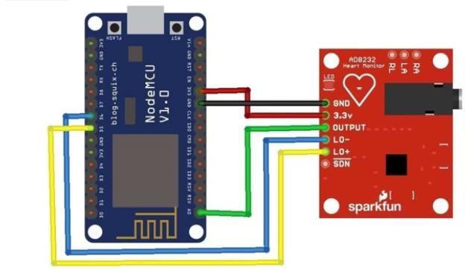**Block Diagram/Schematic**

**Figure: Connection of Arduino UNO to MAX30100 Sensor for measurement of SpO2 levels**

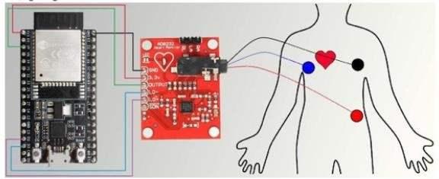

**Figure: Connection of ESP-32 Module to ECG Module AD8232 and ECG Electrodes.**

**ECG Electrodes are placed on the body as shown.**

### Methodology

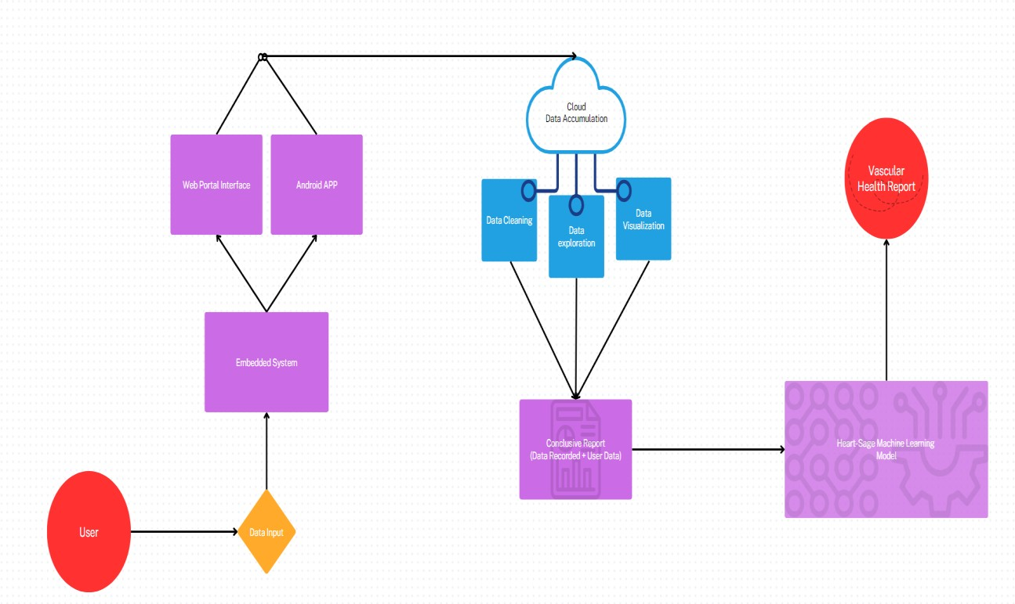

**The Data Input is taken in through Embedded System and displayed on the Web Interface and Android App which is then sent to Cloud for Data Analytics & Cleaning to form a report of Data Recorded from the User which is then sent to HeartSage ML Model for Vascular Health Report.**

### Tools

* Software –
  1. Ubidots
  2. Arduino IDE
  3. Streamlit
  4. Pandas
  5. Visual Studio
* Hardware –

1. Arduino UNO
2. ESP32 devkit
3. OLED display 4. MAX 30100
4. ECG sensor

### Results:-

Current results Phase-2 (Evaluation-1)

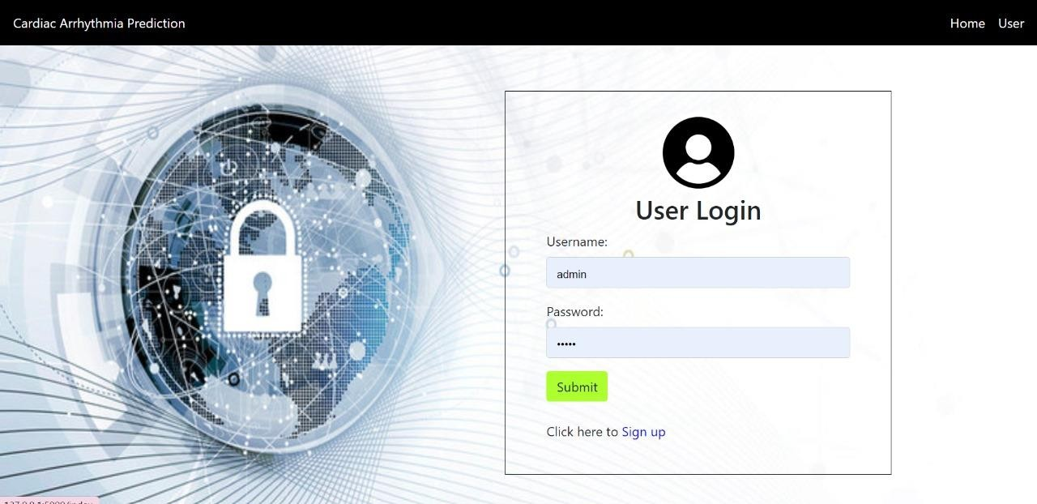

### Fig 1: This is the login page for getting personalized cardiovascular report.

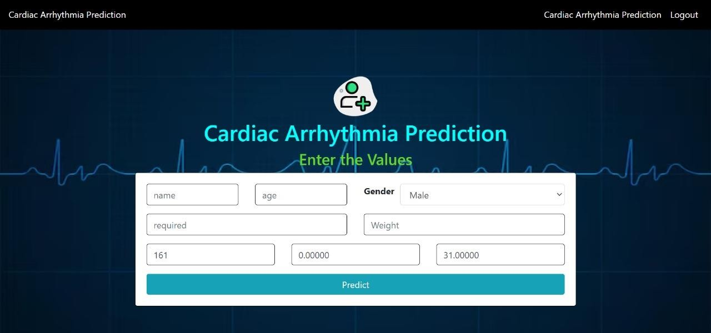

**Fig 2: Specific parameters including height, weight, ECG, heart rate, temperature are given as input to check the cardiovascular health.**

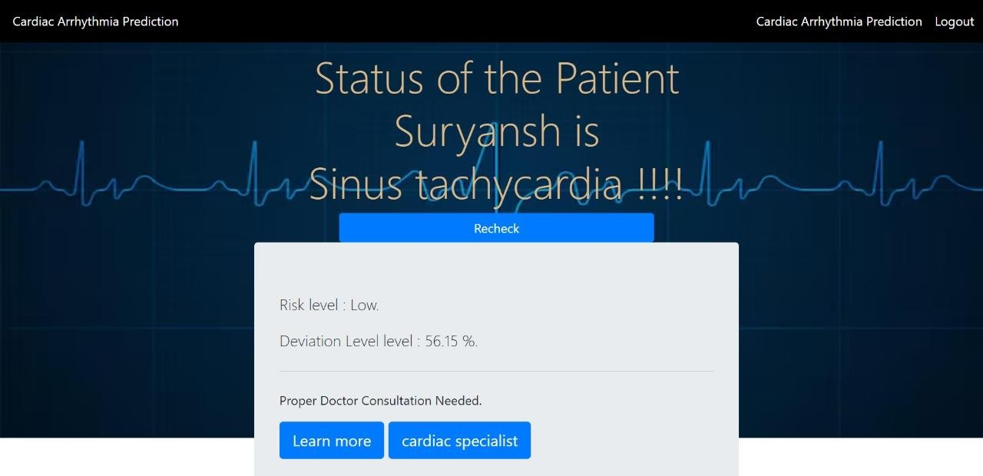

### Fig 3: Final cardiovascular health status, risk level and deviation level is shown as output.

1. **Applications:**

#### Personalized Healthcare Plans:

Heart attack prediction systems can aid in creating personalized healthcare plans for individuals based on their risk levels.

#### Preventive Health Screenings:

Health institutions can use these systems to identify high-risk groups within the population for targeted preventive health screenings.

#### Health Insurance Assessment:

Health insurance companies can utilize these systems to assess the risk of potential policyholders, leading to more accurate risk assessment and appropriate premium adjustments.

### Conclusions

HEARTSAGE: AN ADVANCED ML PREDICTIVE ANALYTICS SYSTEM FOR CARDIOVASCULAR HEALTH**:**

Integration of healthcare with IoT has opened up a vast arena of development. It will not only facilitate healthcare but will also find out new measures to prevent diseases by processing data and by analyzing global trends. Moreover, a vast future lies entirely in the automation of hospitals and treatment mechanisms that can help doctors understand diseases through artificial intelligence and IoT. However, we should take a step at a time and not rush in into this field, since it deals with human health and safety and security needs to be the top agenda. On a large scale, this can also lead to cheaper treatments and cheaper nursing costs for patients. If technology and health go hand in hand, we can reach the goal of cheap, safe, and efficient disease prevention and treatment.

### References

* + V. Sharma, S. Yadav and M. Gupta, "Heart Disease Prediction using Machine Learning Techniques," 2020 2nd International Conference on Advances in Computing, Communication Control and Networking (ICACCCN).
  + J. S. Rose, P. Malin Bruntha, S. Selvadass, R. M. V, B. C. Mary M and M. J. D, "Heart Attack Prediction using Machine Learning Techniques," 2023 9th International Conference on Advanced Computing and Communication Systems (ICACCS).
  + M. Neyja, S. Mumtaz, K. M. S. Huq, S. A. Busari, J. Rodriguez and Z. Zhou, "An IoT- Based E-Health Monitoring System Using ECG Signal," GLOBECOM 2017 - 2017 IEEE Global Communications Conference.
  + O. Y. Tham, M. A. Markom, A. H. A. Bakar, E. S. M. M. Tan and A. M. Markom, "IoT Health Monitoring Device of Oxygen Saturation (SpO2) and Heart Rate Level," 2020 1st International Conference on Information Technology, Advanced Mechanical and Electrical Engineering (ICITAMEE).

**ANNEXURE I**

* 1. **PROGRAM OUTCOMES**

Engineering Graduates will be able to:

1. **Engineering knowledge**: Apply the knowledge of mathematics, science, engineering fundamentals, andan engineering specialization to the solution of complex engineering problems.
2. **Problem analysis**: Identify, formulate, review research literature, and analyze complex engineering problems reaching substantiated conclusions using first principles of mathematics, natural sciences, and engineering sciences.
3. **Design/development of solutions**: Design solutions for complex engineering problems and design system components or processes that meet the specified needs with appropriate consideration for the public health and safety, and the cultural, societal, and environmental considerations.
4. **Conduct investigations of complex problems**: Use research-based knowledge and research methods including design of experiments, analysis and interpretation of data, and synthesis of the information to provide valid conclusions.
5. **Modern tool usage**: Create, select, and apply appropriate techniques, resources, and modern engineering and IT tools including prediction and modeling to complex engineering activities with an understanding of the limitations.
6. **The engineer and society**: Apply reasoning informed by the contextual knowledge to assess societal, health, safety, legal and cultural issues and the consequent responsibilities relevant to the professional engineering practice.
7. **Environment and sustainability**: Understand the impact of the professional engineering solutions in societal and environmental contexts, and demonstrate the knowledge of, and need for sustainable development.
8. **Ethics:** Apply ethical principles and commit to professional ethics and responsibilities and norms of the engineering practice.
9. **Individual and team work**: Function effectively as an individual, and as a member or leader in diverse teams, and in multidisciplinary settings.
10. **Communication**: Communicate effectively on complex engineering activities with the engineering community and with society at large, such as, being able to comprehend and write effective reports and design documentation, make effective presentations, and give and receive clear instructions.
11. **Project management and finance**: Demonstrate knowledge and understanding of the engineering and management principles and apply these to one’s own work, as a member and leader in a team, to manage projects and in multidisciplinary environments.
12. **Life-long learning**: Recognize the need for, and have the preparation and ability to engage in independent and life-long learning in the broadest context of technological change.
    1. **PROGRAM SPECIFIC OUTCOMES (PSOs)**

**PSO1**: Design, develop and integrate electronic circuits and systems using current practices and standards.

**PSO2**: Apply knowledge of hardware and software in designing embedded and communication systems.

## Batch Number:

**PO and PSO Mapping for Project - 2023-24**

|  |  |
| --- | --- |
| **USN** | **Name** |
| 1DS20EC116 | Neeraj Jain |
| 1DS20EC197 | Smarak Mishra |
| 1DS20EC214 | Suryansh Devasthali |
| 1DS20EC215 | Suryansh Saha |

## Guide Name: Dr. Suma M R

**Justification for PO & PSO mapping for Project**

|  |  |  |
| --- | --- | --- |
| **Project Title** | |  |
| **PO** | **Levels 3/2/1** | **Justification** |
| **PO1** | 3 | Engineering knowledge is applied through various electronic circuits and application of algorithms. |
| **PO2** | 1 | Problem analysis is justified accordingly. |
| **PO3** | 2 | An accessible solution is designed in accordance to certain algorithms. |
| **PO4** | 1 | Investigation of complex problems is done and result is to find out an accessible solution. |
| **PO5** | 3 | Modern tools are used such as sensors, python libraries, Arduino etc. |
| **PO6** | 3 | This solution improves the society by developing a solution to maintain day to day health. |
| **PO7** | 1 | Environment and sustainability is justified. |
| **PO8** | 1 | Ethics is justified by developing a solution in accordance to professional ethics and responsibilities. |
| **PO9** | 2 | Full team has dedicated their resources to develop a solution. |
| **PO10** | 3 | Necessary communication was done by conducting team meetings to discuss solutions. |
| **PO11** | 2 | Project management and finance was justified by principles. |
| **PO12** | 2 | Life long learning is achieved by future working this solution. |
| **PSO1** | 3 | Electronic circuits and systems are designed using current practices and standards. |
| **PSO2** | 3 | Hardware and software knowledge is applied. |

**Signature of Guide**

**Batch Number:**

# Budget Estimation

|  |  |
| --- | --- |
| **USN** | **Name** |
| 1DS20EC116 | Neeraj Jain |
| 1DS20EC197 | Smarak Mishra |
| 1DS20EC214 | Suryansh Devasthali |
| 1DS20EC215 | Suryansh Saha |

## Guide Name:

|  |  |  |
| --- | --- | --- |
| **Sl. No.** | **Particulars** | **Estimated Cost in Rs.** |
| 1 | Max 30100 Pulse Sensor | 150 |
| 2 | ESP32D PCB Module | 340 |
| 3 | OLED 1.3”-White | 350 |
| 4 | Arduino UNO R3-Compatible Clone | 500 |
| 5 | HC05 6pin Bluetooth Module | 225 |
| 6 | ECG Sensor Module AD8232 | 450 |
| 7 | Breadboard 800 Points GL-12 | 120 |
| 8 | Data Transfer USB Cables | 250 |
| 9 | Data Transfer Printer Cables | 200 |
| 10 |  |  |
| 11 |  |  |
| 12 |  |  |
| Total | | 3200 |

#### Signature of Guide